1. ‘Data type of columns in a table’

SELECT

COLUMN_NAME,

DATA_TYPE

FROM

target-sql-359616.target_data.INFORMATION_SCHEMA.COLUMNS

WHERE

TABLE_SCHEMA = 'target_data'

AND TABLE_NAME = 'sellers'

AND COLUMN_NAME IN ('seller_id',

'seller_zip_code_prefix',

'seller_city',

'seller_state')

Output :

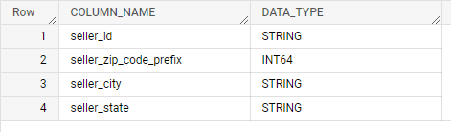

SELECT

COLUMN_NAME,

DATA_TYPE

FROM

target-sql-359616.target_data.INFORMATION_SCHEMA.COLUMNS

WHERE

TABLE_SCHEMA = 'target_data'

AND TABLE_NAME = 'payments'

AND COLUMN_NAME IN ('order_id',

'payment_sequential',

'payment_type',

'payment_installments',

'payment_value')

Output :

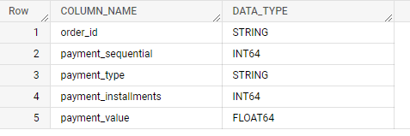

1. ‘Time period for which the data is given’

Query:

SELECT

min(order_purchase_timestamp) as start_time_period,max(order_purchase_timestamp) as end_time_period

FROM

Target-sql-359616.target_data.orders

Output:

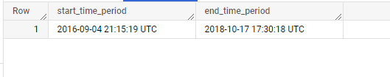

**OR**

SELECT

extract(year from min(order_purchase_timestamp)) as start_time_period, extract(year from max(order_purchase_timestamp)) as end_time_period

FROM

target-sql-359616.target_data.orders

Output:



1. Cities and States covered in the dataset

Query :

WITH

base AS (

SELECT

DISTINCT customer_city,

customer_state

FROM

target-sql-359616.target_data.customers),

base1 AS (

SELECT

DISTINCT seller_city,

seller_state

FROM

target-sql-359616.target_data.sellers),

base2 AS (

SELECT

geolocation_city,

geolocation_state

FROM

target-sql-359616.target_data.geolocation

GROUP BY

geolocation_city, geolocation_state)

SELECT

customer_state as states,

customer_city as cities

FROM(

SELECT *

FROM base

UNION DISTINCT

SELECT *

FROM base1

UNION DISTINCT

SELECT *

FROM base2)

Output:

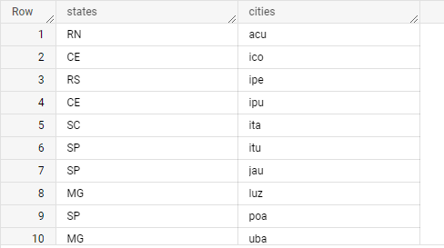

1. Is there a growing trend on e-commerce in Brazil?

Query:

SELECT

CONCAT(YEAR_OF_PURCHASE,'/',MONTH_OF_PURCHASE) AS purchase_year_month,

YEAR_OF_PURCHASE,

MONTH_OF_PURCHASE,

WEEK_OF_PURCHASE,

ORDER_COUNT

FROM(

SELECT

EXTRACT(YEAR

FROM

order_purchase_timestamp) AS YEAR_OF_PURCHASE,

EXTRACT(MONTH FROM order_purchase_timestamp) As MONTH_OF_PURCHASE,

EXTRACT(WEEK FROM order_purchase_timestamp) AS WEEK_OF_PURCHASE,

COUNT(order_id) AS ORDER_COUNT

FROM

target-sql-359616.target_data.orders

GROUP BY

EXTRACT(YEAR

FROM

order_purchase_timestamp),

EXTRACT(MONTH FROM order_purchase_timestamp),

EXTRACT(WEEK FROM order_purchase_timestamp)

)

ORDER BY YEAR_OF_PURCHASE, MONTH_OF_PURCHASE, WEEK_OF_PURCHASE

Output:

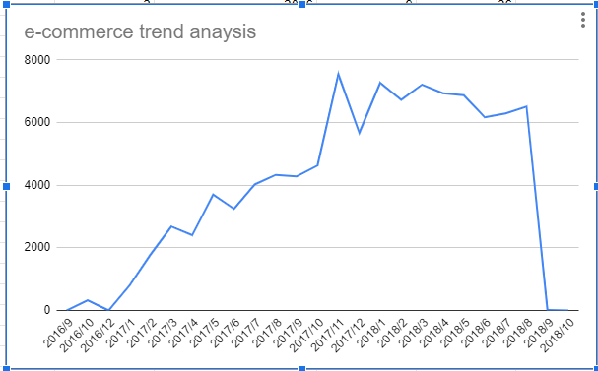

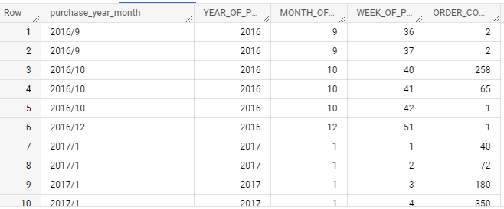

Can we see some seasonality with peaks at specific months?

SELECT

EXTRACT(MONTH FROM order_purchase_timestamp) As MONTH_OF_PURCHASE,

COUNT(order_id) AS ORDER_COUNT

FROM

target-sql-359616.target_data.orders

GROUP BY MONTH_OF_PURCHASE

ORDER BY MONTH_OF_PURCHASE

OUTPUT :

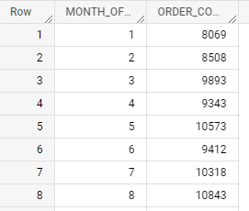

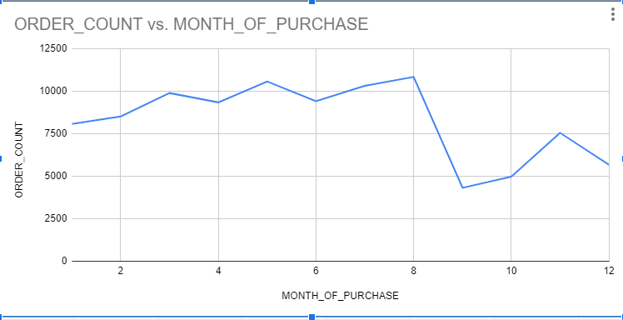

1. What time do Brazilian customers tend to buy (Dawn, Morning, Afternoon or Night)?

SELECT

CASE

WHEN EXTRACT(hour FROM timestamp(order_purchase_timestamp)) BETWEEN 0

AND 6

THEN 'dawn'

WHEN EXTRACT(hour FROM timestamp(order_purchase_timestamp)) BETWEEN 7

AND 12

THEN 'morning'

WHEN

EXTRACT(hour FROM timestamp(order_purchase_timestamp))

BETWEEN 13

AND 18

THEN 'afternoon'

WHEN

EXTRACT(hour FROM timestamp(order_purchase_timestamp))

BETWEEN 19

AND 23

THEN 'night'

END AS time_of_day,

COUNT(DISTINCT order_id) AS counter

FROM `target-sql-359616.target_data.orders`

GROUP BY 1

ORDER BY 2 DESC;

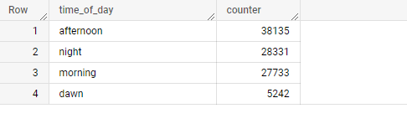

1. Get month on month orders by region, states

SELECT g.geolocation_state,EXTRACT(MONTH FROM o.order_purchase_timestamp) AS month, COUNT(o.order_id) AS ORDER_COUNT

FROM `target-sql-359616.target_data.orders` o

JOIN `target-sql-359616.target_data.customers` c

ON o.customer_id = c.customer_id

JOIN `target-sql-359616.target_data.geolocation` g

ON c.customer_zip_code_prefix = g.geolocation_zip_code_prefix

GROUP BY g.geolocation_state,month

ORDER BY g.geolocation_state,month

OUTPUT:

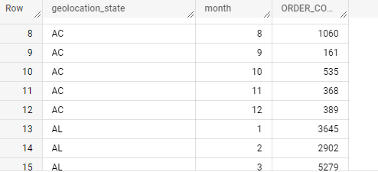

1. How are customers distributed in Brazil

SELECT g.geolocation_state,COUNT(DISTINCT c.customer_id) AS Customer_Count

FROM `target-sql-359616.target_data.customers` c

JOIN `target-sql-359616.target_data.geolocation` g

ON c.customer_zip_code_prefix = g.geolocation_zip_code_prefix

GROUP BY g.geolocation_state

ORDER BY g.geolocation_state

OUTPUT:

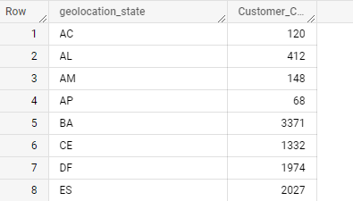

1. Get % increase in cost of orders from 2017 to 2018 (include months between Jan to Aug only)

WITH base AS(

SELECT EXTRACT(YEAR FROM o.order_purchase_timestamp) AS year, EXTRACT(MONTH FROM o.order_purchase_timestamp) AS month,sum(oi.price) AS SUM_PRICE

FROM `target-sql-359616.target_data.order_items` oi

JOIN `target-sql-359616.target_data.orders` o

ON oi.order_id = o.order_id

JOIN `target-sql-359616.target_data.customers` c

ON o.customer_id = c.customer_id

GROUP BY year,month

ORDER BY year,month

),

base1 AS (

SELECT

SUM(CASE WHEN year = 2017 AND month BETWEEN 1 AND 8 THEN SUM_PRICE else 0 END) AS price_2017_yr,

SUM(CASE WHEN year = 2018 AND month BETWEEN 1 AND 8 THEN SUM_PRICE else 0 END) AS price_2018_yr,

FROM base

)

#SELECT * FROM base

SELECT price_2017_yr,price_2018_yr,(price_2018_yr - price_2017_yr) / (price_2017_yr) * 100 AS price_percentage_increase

FROM base1

OUTPUT:

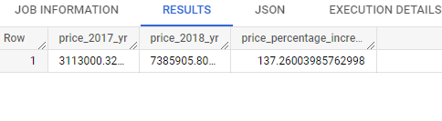

1. Mean & Sum of price and freight value by customer state

SELECT c.customer_state, sum(oi.price) AS SUM_PRICE, sum(oi.price)/COUNT(DISTINCT oi.order_id) As AVG_PRICE,

sum(oi.freight_value) AS SUM_FV, sum(oi.freight_value)/COUNT(DISTINCT oi.order_id) AS AVG_FV,

FROM `target-sql-359616.target_data.order_items` oi

JOIN `target-sql-359616.target_data.orders` o

ON oi.order_id = o.order_id

JOIN `target-sql-359616.target_data.customers` c

ON o.customer_id = c.customer_id

GROUP BY c.customer_state

ORDER BY c.customer_state

OUTPUT:

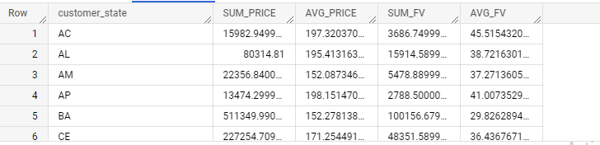

1. Calculate days between purchasing, delivering and estimated delivery

SELECT

date_diff(o.order_estimated_delivery_date,o.order_purchase_timestamp,DAY) AS estimated_delivery_days,

date_diff(o.order_delivered_customer_date,o.order_estimated_delivery_date,DAY) AS actual_delivery_days

FROM `target-sql-359616.target_data.orders` o

WHERE order_status = 'delivered'

OUTPUT:

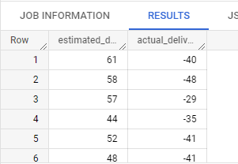

1. Create columns:
   * time_to_delivery = order_purchase_timestamp-order_delivered_customer_date
   * diff_estimated_delivery = order_estimated_delivery_date-order_delivered_customer_date

SELECT

date_diff(date(o.order_purchase_timestamp),date(o.order_estimated_delivery_date), Day) AS time_to_delivery ,

date_diff(date(o.order_estimated_delivery_date),date(o.order_delivered_customer_date), Day) AS diff_estimated_delivery ,

FROM `target-sql-359616.target_data.orders` o

WHERE o.order_status = 'delivered'

OUTPUT:

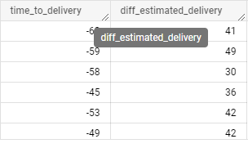

1. Group data by state, take mean of freight_value, time_to_delivery, diff_estimated_delivery

SELECT

geolocation_state,geolocation_city,

SUM(freight_value)/COUNT(DISTINCT order_id) AS AVG_FV,

SUM(time_to_delivery)/COUNT(DISTINCT order_id) AS AVG_time_to_delivery,

SUM(diff_estimated_delivery)/COUNT(DISTINCT order_id) AS AVG_diff_estimated_delivery

FROM(

SELECT o.order_id,oi.freight_value,g.geolocation_state,g.geolocation_city,

ABS(date_diff(date(o.order_purchase_timestamp),date(o.order_estimated_delivery_date), Day)) AS time_to_delivery ,

ABS(date_diff(date(o.order_estimated_delivery_date),date(o.order_delivered_customer_date), Day)) AS diff_estimated_delivery ,

FROM `target-sql-359616.target_data.orders` o

JOIN `target-sql-359616.target_data.order_items` oi

ON o.order_id = oi.order_id

JOIN `target-sql-359616.target_data.customers` c

ON o.customer_id = c.customer_id

JOIN `target-sql-359616.target_data.geolocation` g

ON c.customer_zip_code_prefix = g.geolocation_zip_code_prefix

WHERE o.order_status = 'delivered'

) AS temp

GROUP BY geolocation_state,geolocation_city

ORDER BY geolocation_state

OUTPUT :

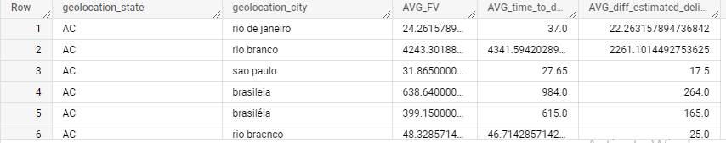

1. Sort the data to get the following:
   1. Top 5 states with highest/lowest average freight value - sort in desc/asc limit 5
   2. Top 5 states with highest/lowest average time to delivery
   3. Top 5 states where delivery is really fast/ not so fast compared to estimated date

SELECT

geolocation_state,

SUM(freight_value)/COUNT(DISTINCT order_id) AS AVG_FV,

SUM(time_to_delivery)/COUNT(DISTINCT order_id) AS AVG_time_to_delivery,

SUM(diff_estimated_delivery)/COUNT(DISTINCT order_id) AS AVG_diff_estimated_delivery

FROM(

SELECT o.order_id,oi.freight_value,g.geolocation_state,g.geolocation_city,

ABS(date_diff(date(o.order_purchase_timestamp),date(o.order_estimated_delivery_date), Day)) AS time_to_delivery ,

ABS(date_diff(date(o.order_estimated_delivery_date),date(o.order_delivered_customer_date), Day)) AS diff_estimated_delivery ,

FROM `target-sql-359616.target_data.orders` o

JOIN `target-sql-359616.target_data.order_items` oi

ON o.order_id = oi.order_id

JOIN `target-sql-359616.target_data.customers` c

ON o.customer_id = c.customer_id

JOIN `target-sql-359616.target_data.geolocation` g

ON c.customer_zip_code_prefix = g.geolocation_zip_code_prefix

WHERE o.order_status = 'delivered'

) AS temp

GROUP BY geolocation_state

ORDER BY AVG_FV DESC,geolocation_state ASC

LIMIT 5

OUTPUT:

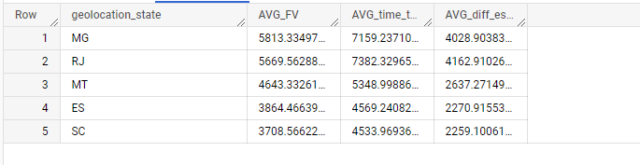

SELECT

geolocation_state,

SUM(freight_value)/COUNT(DISTINCT order_id) AS AVG_FV,

SUM(time_to_delivery)/COUNT(DISTINCT order_id) AS AVG_time_to_delivery,

SUM(diff_estimated_delivery)/COUNT(DISTINCT order_id) AS AVG_diff_estimated_delivery

FROM(

SELECT o.order_id,oi.freight_value,g.geolocation_state,g.geolocation_city,

ABS(date_diff(date(o.order_purchase_timestamp),date(o.order_estimated_delivery_date), Day)) AS time_to_delivery ,

ABS(date_diff(date(o.order_estimated_delivery_date),date(o.order_delivered_customer_date), Day)) AS diff_estimated_delivery ,

FROM `target-sql-359616.target_data.orders` o

JOIN `target-sql-359616.target_data.order_items` oi

ON o.order_id = oi.order_id

JOIN `target-sql-359616.target_data.customers` c

ON o.customer_id = c.customer_id

JOIN `target-sql-359616.target_data.geolocation` g

ON c.customer_zip_code_prefix = g.geolocation_zip_code_prefix

WHERE o.order_status = 'delivered'

) AS temp

GROUP BY geolocation_state

ORDER BY AVG_time_to_delivery DESC,geolocation_state ASC

LIMIT 5

OUTPUT:

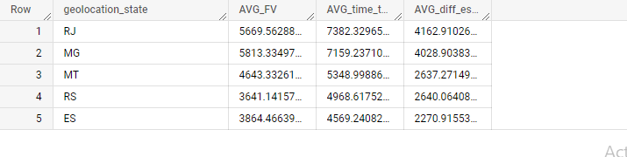

SELECT

geolocation_state,

SUM(freight_value)/COUNT(DISTINCT order_id) AS AVG_FV,

SUM(time_to_delivery)/COUNT(DISTINCT order_id) AS AVG_time_to_delivery,

SUM(diff_estimated_delivery)/COUNT(DISTINCT order_id) AS AVG_diff_estimated_delivery

FROM(

SELECT o.order_id,oi.freight_value,g.geolocation_state,g.geolocation_city,

ABS(date_diff(date(o.order_purchase_timestamp),date(o.order_estimated_delivery_date), Day)) AS time_to_delivery ,

ABS(date_diff(date(o.order_estimated_delivery_date),date(o.order_delivered_customer_date), Day)) AS diff_estimated_delivery ,

FROM `target-sql-359616.target_data.orders` o

JOIN `target-sql-359616.target_data.order_items` oi

ON o.order_id = oi.order_id

JOIN `target-sql-359616.target_data.customers` c

ON o.customer_id = c.customer_id

JOIN `target-sql-359616.target_data.geolocation` g

ON c.customer_zip_code_prefix = g.geolocation_zip_code_prefix

WHERE o.order_status = 'delivered'

) AS temp

GROUP BY geolocation_state

ORDER BY AVG_diff_estimated_delivery ASC,geolocation_state ASC

LIMIT 5

OUTPUT:

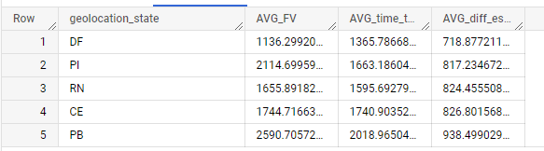

1. Payment type analysis:
   1. Month over Month count of orders for different payment types
   2. Distribution of payment installments and count of orders

SELECT

p.payment_type,

#EXTRACT(YEAR FROM o.order_purchase_timestamp) AS year,

EXTRACT(MONTH FROM o.order_purchase_timestamp) AS month,

COUNT(o.order_id) AS ORDER_COUNT

FROM `target-sql-359616.target_data.orders` o

JOIN `target-sql-359616.target_data.payments` p

ON o.order_id = p.order_id

GROUP BY p.payment_type,month

ORDER BY p.payment_type,month

OUTPUT:

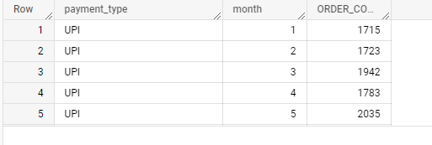

SELECT

p.payment_type,

#EXTRACT(YEAR FROM o.order_purchase_timestamp) AS year,

#EXTRACT(MONTH FROM o.order_purchase_timestamp) AS month,

COUNT(o.order_id) AS ORDER_COUNT

FROM `target-sql-359616.target_data.orders` o

JOIN `target-sql-359616.target_data.payments` p

ON o.order_id = p.order_id

GROUP BY p.payment_type

ORDER BY p.payment_type

OUTPUT:

